Draft_Publisher Report

Table of Contents

Publisher Report 1

Publisher Report 1

Prerequisites 1

Introduction to Publisher Report 2

Components of a Publisher Report 3

Creating Templates 11

Creating Templates 11

Output Compliance Matrix 12

Creating an Excel Template 13

Creating a Word Template 18

Creating a HTML Template 19

Creating a FTL Template 26

Creating an Excel Template for Grouping 32

Applying Templates to Publisher Report 34

Applying Templates to Publisher Report 34

Applying Excel Template to Publisher Report 35

Applying Word Template to Publisher Report 40

Applying HTML Template to Publisher Report 42

Applying FTL Template to Publisher Report 44

# Publisher Report

## Publisher Report

### Prerequisites

In order to work successfully with Publisher Report, knowledge of SQL queries is useful.

**T**his chapter introduces you to the Publisher Report. Specifically, this chapter teaches you about:

* Introduction
* Components of Publisher Report
* Creating Publisher Report
* Creating Templates
* Applying Templates

## Introduction to Publisher Report

ORBIT **Publisher Report**  provides the ability to **Create** and **Manage** formatted reports from a wide range of **Data Sources**.

You can design Templates for your Publisher reports using the below list

* Microsoft Word
* MIcrosoft Excel
* HTML
* FTL

Templates created using the above-mentioned tools contain embedded fields with Properties that determine how the data will be merged into the Template.

Publisher Report separates the data creation from the process of formatting it for different uses. It creates custom reports on any Query and offers support for multiple Output Types.

**Note: Prior to creating Publisher report in Orbit, you must have different existing templates.**

## Components of a Publisher Report

For a Publisher Reports, the following components appear when a Band is selected:

* + Business Object Area (highlighted as “1”)
  + Bands (highlighted as “2”)
  + Band Details (highlighted as “3”)
  + User Filters area (highlighted as “4”)

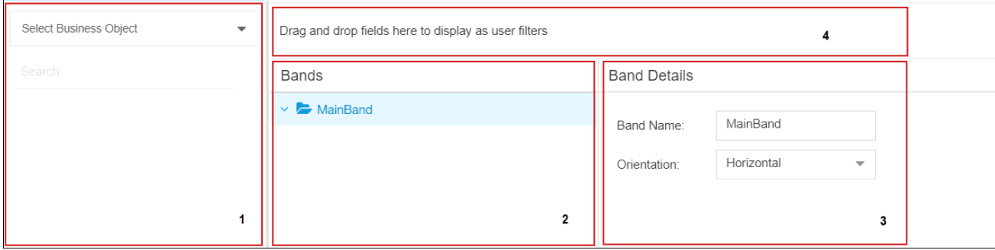

**Business Objects Area**

This section displays the available **Business Object**. When a business object is selected, available objects are displayed.

**Bands**

Bands section holds the Reports Structured template which we want to set them as default i.e. **Header,Footer.**

It comprises of

* Main Band (Root Band)
* New Band (Header)
  + Query(Where the Data values are set)

We can create any number of New Bands based on the requirement.

|  |
| --- |
| Note:   * When a Band is selected **Band Details** appear on the right. * When we click Query, **Query Details** are displayed on the right. * Band Name must be the same as we mention in  the **Name field in the Excel/Word/HTML templates**. |

**Band Details**

When a band is selected (here **Header**), its corresponding band details appear on the right under **Band Details** section.

Under **Band Details**, the following parameters appear:

* **Band Name**
* **Orientation: Horizontal or Vertical**

**Note: Horizontal Bands are copied downwards and Vertical to the right. Horizontal bands may contain sub-bands.**

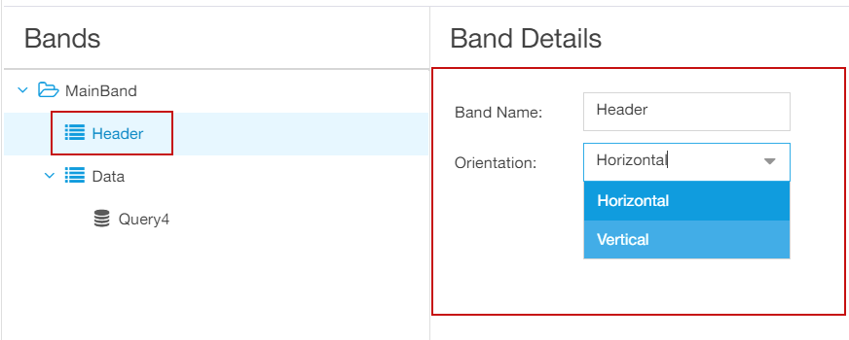

**User Filters**

User Filters are parameter-based filters that allow the user to input a value to filter the data in the report.

For a Publisher Report, the following components appear when a query is selected:

* Business Object Area (highlighted as “1”)
* Bands (highlighted as “2’)
* Query Details (highlighted as “3”) (This appears when a query is selected in **Bands** section.)
* Query (highlighted as “4”) (This appears when a query is selected in **Bands** section.)
* User Filter area (highlighted as “5”)

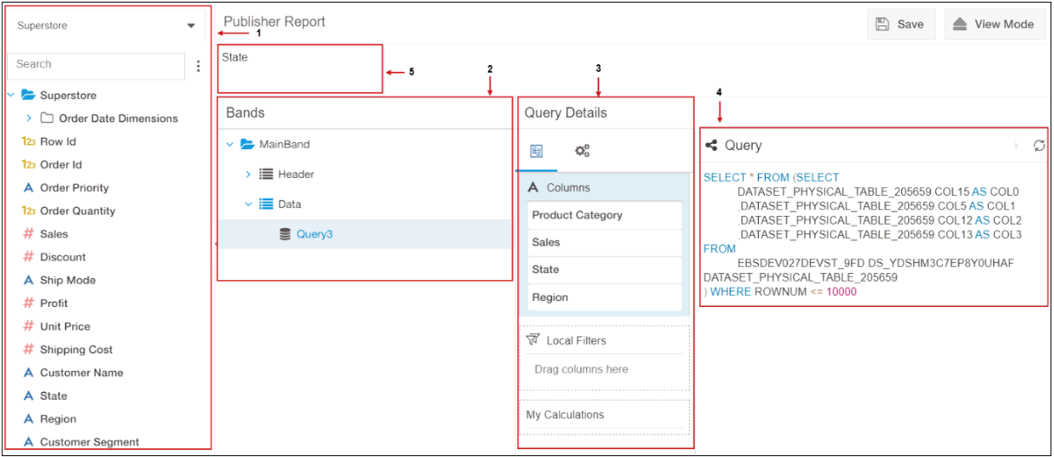

**Query Details**

**Query Details** section has the following:

* + **Configurator-** The objects dragged from BO area appear here. Based on the **Columns** in this section, query is built under **Query** section.
  + **Local Filters -** They are used to segregate huge data in the database while building reports.
  + **(Query Settings)** - This section provides the option to configure Row Limit, Query Timeout, and Select Distinct options.

**Query**

When the columns are dragged into the **Configurator** from BO area into **Query Details**, the query is automatically generated in **Query** section.

Creating a Publisher Report

**Steps to Create a Publisher Report**

1. In the Orbit Application click  **Reports**, click  **New Report,** and then click **Publisher Report**.
2. A new window appears with **Select Business Object**, **Bands**, and **Band Details** sections (highlighted as “1”).
3. In the **Select Business Object** area, select the required Business object.
4. The columns under the selected business object (highlighted as “2”) appear.

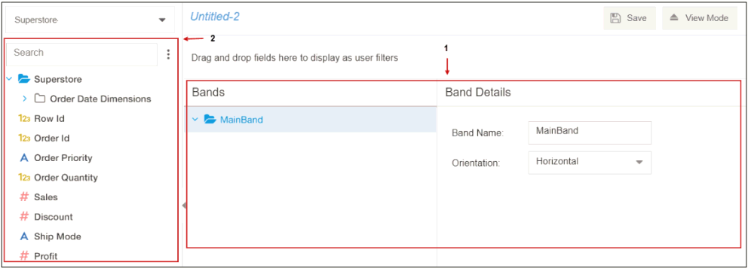

1. Under the **Bands** section, **MainBand** appears.

|  |
| --- |
| Note:   * One band can have multiple child bands under it and a band can also have multiple queries under it. * Bands in the Publisher Report maps to Names in Excel sheet. |

1. On the MainBand, right-click and then select **New Band** to create a new band (OR) Hover the cursor on the MainBand, click , and then click **New Band** (highlighted as “3”)..

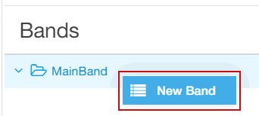        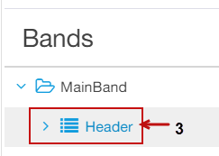

 When a specific band is selected, the **Band Details** appear on the Right side.(highlighted as “4”).

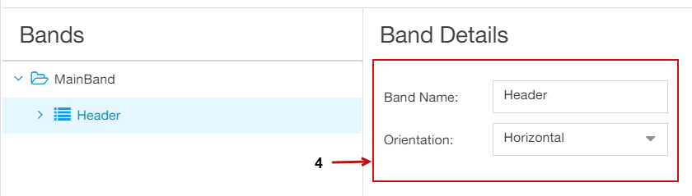

|  |
| --- |
| Note:   * You can change the Band name either by double-clicking it or you can change it under **Band Details.** * The default orientation is **Horizontal**. You can change the orientation to **Vertical** as well. The orientation describes direction of the data display. * Here, **Header** band is for the Header band that we created in the excel sheet. Now, we would be creating data band to extract the data under **Header.** |

1. On the **MainBand**, right-click and then select **New Band** to create a new band (OR) Hover the cursor on the **MainBand**, click , and then click **New Band**.
2. On the **Data** band (highlighted as “5”), right-click, and then Select **New Query** (OR)Hover the cursor on the **Data** band, click , and then click **New Query**.
3. **Query Details** (highlighted as “7”) and **Query** (highlighted as “8”) sections appear.

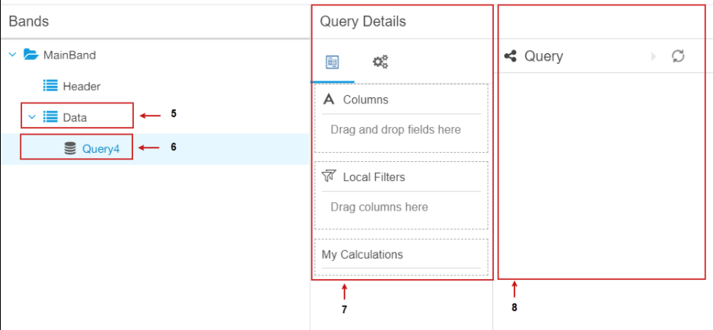

1. Drag and drop the objects into the Columns from Business Object area to the **Configurator** under **Query Details.**
2. To build your own Calculation , click ****next to **My calculations** and then click **New Calculation.**
3. **Calculation Formula** dialogue box appears, we need to enter the required fields as mentioned below.

* **Name:** Type the required name.
* **Datatype:** Click the dropdown to select the required type as **Number,Text,Date or Integer**
* **Function Types:** Based on the Datatype selected the Function types are displayed**.**
* **Function:** As per the Function Types selected the related Functions are displayed.

E.g. If we **Select** the Function Types as Date Functions we can view Functions such as YEAR, MONTH, TO_DATE.

    13. Build the required formula in **formula field** and then Click **OK**(highlighted as “9”).

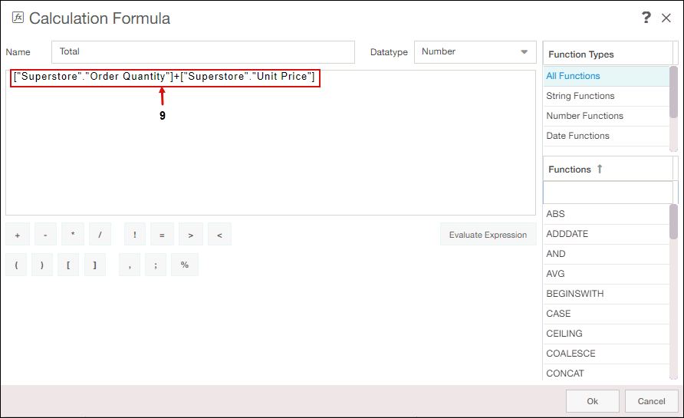

14. Under the **Query** section, a query is built based on the dragged columns.

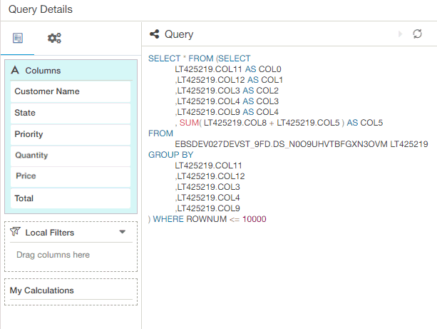`

15. Save the report under appropriate folder, by clicking **Save** a message of **Report saved Successfully** appears on the top.

## Creating Templates

### Creating Templates

This section deals with creating the following:

* Creating an Excel Template
* Creating a Word Template
* Creating a HTML Template
* Creating a FTL Template
* Creating an Excel Template for Grouping

### Output Compliance Matrix

To view the output in **PDF**, Configure **OpenOffice 4.x or higher for Linux/Windows.**

**A**lternatively, you can also Configure **LibreOffice5.x or higher for Windows/Linux** to view the output in **PDF**.

|  |  |  |  |  |  |  |  |
| --- | --- | --- | --- | --- | --- | --- | --- |
| **Template / Output** | **XLSX** | **XLS** | **DOCX** | **DOC** | **PDF** | **HTML** | **TXT** |
| **XLSX** |  |  |  |  |  |  |  |
| **XLS** |  |  |  |  |  |  |  |
| **DOCX** |  |  |  |  |  |  |  |
| **DOC** |  |  |  |  |  |  |  |
| **HTML** |  |  |  |  |  |  |  |
| **FTL** |  |  |  |  |  |  |  |
|  | | | | | | | |

### Creating an Excel Template

**Steps to Create an Excel Template**

1. Open the **Excel Sheet**.
2. In the Excel sheet, enter the Header (E.g Company Name) in the column as shown in the below figure (highlighted as 1)

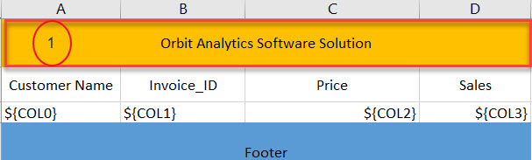

3. Enter the required field Names (E.g Customer Name, Invoice_ID) to extract the column values under it as shown in below figure (highlighted as 2)

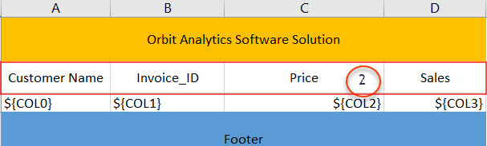

 4. Enter the column values **${COL0}**, **${COL1}** and so on, these should be the same as mentioned in the **Query** section in Publisher Report. As shown in the figure below,

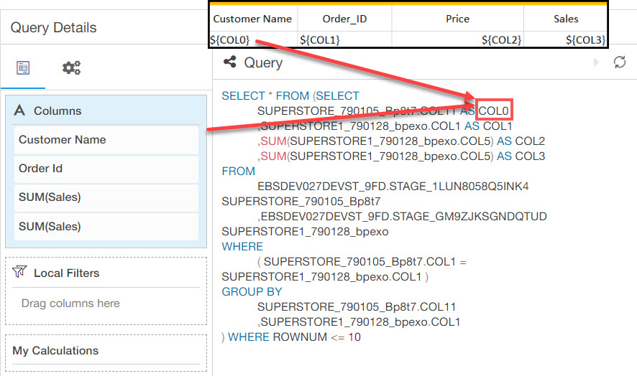

Now,create different **Names**( E.g Header, Footer etc.) in the Excel sheet similar to **Bands** name in **Orbit Publisher Report**.   
    
    
**Steps to Create a Name in Excel Sheet**

1. On the Ribbon click **Formulas**, in the **Defined Names** group, click **Name Manager.**

**2. Name Manager** dialog box appears.

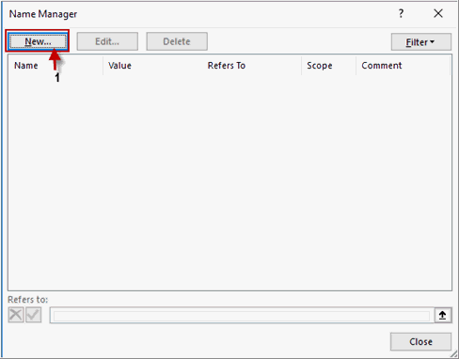

3. To create a new band, click **New** (highlighted as “1”).

**4. New Name** dialog box appears.

5. In the **New Name** dialog box, perform the following:

* In the **Name** box, type the name of the band.

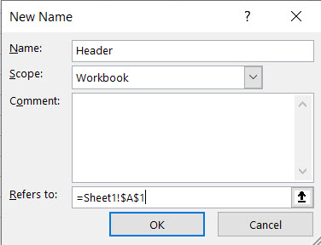

* To enter the values in the **Refers to** box, click  beside the **Refers to.**
* **New Name – Refers to** dialog box appears with the cursor inside the textbox, once the required cells are selected the formula appears, refer the below image.

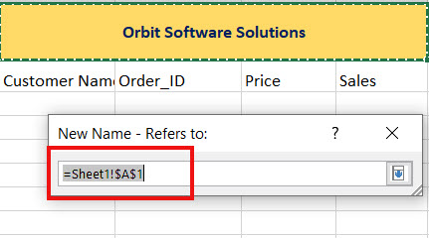

* Click to navigate to the **New Name dialogue box.**
* The selected cell values appear in the **Refers to** textbox as shown in the figure below.

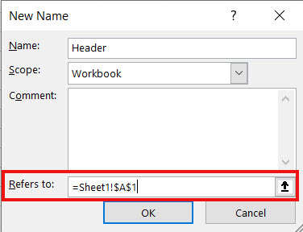

* To save the changes, click **OK**.
* The Band name appears in the **Name Manager** dialog box as shown in the figure below.

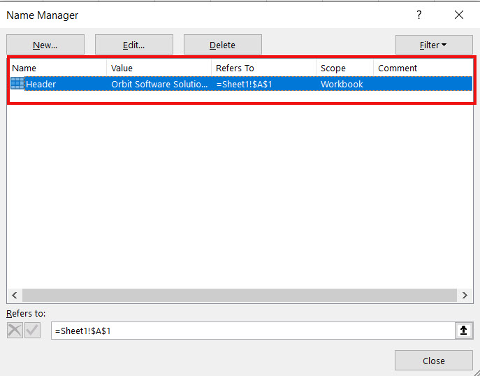

* To close the dialog box, click **Close**.
* Now create a **New Name band** “**Data**”, and place the column values **${COL0}, ${COL1}** and so on in the **Data** band using the above process.
* Save the Workbook with an appropriate name and click Close.

|  |
| --- |
| Note:   * Table and Pivot cannot be used for creating templates in Excel. |

### Creating a Word Template

**Steps to Create a Word Template:**

1. Open the **Word document.**

2. Mention the header as “${ReportData.COL1}".

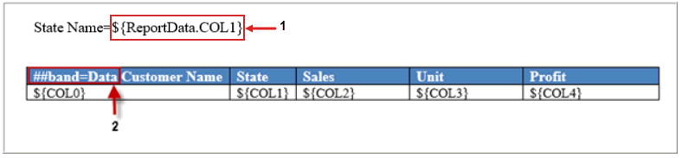

For E.g. State is mentioned as a filter.

3. As shown in the figure above, to retrieve the customer data, specify the band as “**##band=Data**” (highlighted as “1”).

4. Type the required **Column Names.**

5. To extract the column values under the required columns, enter the column numbers as ${COL0}, ${COL1}, and so on.

6. Save the word document with an appropriate name.

To retrieve the data in multiple rows, it essential to create a table in Word template.

### Creating a HTML Template

The following code provides the required style elements for the HTML template. The style elements must be placed between <head> and </head> tags.

<head> <meta charset="UTF-8"> <title>Untitled Document</title> <style type="text/css"> .report-table-details {

 margin-bottom: 0px;

 border: solid #dfdcdc 1px;

 min-width: 550px;

}

.report-table-details th {

 background: #1777cb;

 padding-top: 8px;

 padding-bottom: 8px;

 color: #fff;

 text-align: left;

 padding-left: 20px;

 font-size: 14px;

 font-family: lato;

}

.report-table-details td {

 padding-top: 10px;

 padding-bottom: 10px;

 padding-left: 20px;

 padding-right: 20px;

 color: #fff;

 font-family: lato;

 font-size: 14px;

 border-right: 1px solid #dfdcdc;

 border-bottom: 1px solid #dfdcdc;

}

.report-table-details td:first-child {

 font-weight: bold;

 color: #5a5a5a

}

.report-table-details td:last-child {

 padding-left: 20px;

 color: #1777cb;

 border-right: none

}

.report-table-details tr:last-child td {

 border-bottom: none

}

.report-table {

 border: solid #dfdcdc 1px;

 font-family: lato;

}

.report-table th {

 background-color: #1777cb;

 color: #fff;

 font-size: 14px;

 padding-top: 10px;

 padding-bottom: 10px;

 border-right: 1px solid #dfdcdc;

 text-align: left;

 padding-left: 30px;

}

.report-table th:last-child {

 border-right: none;

}

.report-table td {

 color: #5a5a5a;

 font-size: 13px;

 padding-left: 30px;

 border-right: 1px solid #dfdcdc;

 border-bottom: 1px solid #dfdcdc;

 padding-top: 8px;

 padding-bottom: 8px;

}

.report-table td:last-child {

 border-right: none;

}

.report-table tr:nth-child(even) {

 background: #fff

}

.report-table tr:nth-child(odd) {

 background: #f8f8f8

}

.reportgrid-title {

 font-size: 40px;

 color: #5a5a5a;

 font-family: lato;

 float: left;

 font-weight: bold;

 margin-bottom: 20px;

 margin-top: 20px;

}

.report-table tr:last-child td {

  border-bottom: none

}

.details-div {

 clear: left;

}

.cust-logo {

 float: right;

 margin-top: 30px;

 margin-right: 30px;

}

.cust-logo img {

 width: 130px;

}

</style> </head>

The following code provides the data for the required columns. Place the following code in between the tags <body> </body>.

**Band is assigned in the following code as <#assign groups = Root.bands.Header>.**

<body>

 <div style="margin: 0px auto;">

 <div class="details-div">

 <#assign groups=Root.bands.Header>

 <br>

 <#list groups as Hname>

 <table width="100%" class="report-table" border="0" cellpadding="0" cellspacing="0">

  <tbody>

 <tr>

 <th scope="col">Name</th>

 <th scope="col">${Hname.fields.COL0}</th>

 </tr>

 <tr>

 <th> CUTOMER NAME</th>

 <th> PRIORITY</th>

 <th> ORDER DATE</th>

 <th> QUANTITY </th>

 <th> UNIT PRICE</th>

 <th> TOTAL</th>

 </tr>

 <#list Hname.bands.Data as data>

 <tr>

 <td nowrap=true> ${data.fields.COL0} </td>

 <td nowrap=true> ${data.fields.COL1} </td>

 <td nowrap=true> ${data.fields.COL2} </td>

 <td nowrap=true> ${data.fields.COL3} </td>

  <td nowrap=true> ${data.fields.COL4} </td>

 <td nowrap=true> ${data.fields.COL5} </td>

 </tr>

 </#list>

 </tbody>

 </table>

 </#list>

 </div>

 </div>

</body>   
    
    
    
    
    
    
    
    
 

### Creating a FTL Template

The output for FTL Templates is available in the following formats:

* **HTML**
* **TXT**

FTL Template for HTML Output

**To create FTL Template**

* The following code provides the required style elements for the FTL Template.
* The output appears in HTML. The style elements must be placed between <head> and </head> tags.

*<head>*

*<meta charset="UTF-8">*

*<title>Untitled Document</title>*

*<style type="text/css">*

*.report-table-details{ margin-bottom: 0px; border: solid #dfdcdc 1px; min-width: 550px; }*

*.report-table-details th{background: #1777cb; padding-top: 8px; padding-bottom: 8px;  color: #fff; text-align:left; padding-left: 20px; font-size: 14px;font-family: lato;}*

*.report-table-details td{ padding-top:10px; padding-bottom: 10px; padding-left: 20px; padding-right: 20px;color: #fff; font-family: lato;  font-size: 14px;border-right: 1px solid #dfdcdc; border-bottom: 1px solid #dfdcdc; }*

*.report-table-details td:first-child{font-weight: bold; color:#5a5a5a}*

*.report-table-details td:last-child{ padding-left:20px; color: #1777cb; border-right: none}*

*.report-table-details tr:last-child td{border-bottom: none}*

*.report-table{border: solid #dfdcdc 1px; font-family: lato; }*

*.report-table th{ background-color: #1777cb; color: #fff; font-size:14px; padding-top: 10px; padding-bottom: 10px;*

*border-right: 1px solid #dfdcdc; text-align: left; padding-left: 30px;}*

*.report-table th:last-child{border-right: none;}*

*.report-table td{  color: #5a5a5a;font-size: 13px; padding-left: 30px;border-right: 1px solid #dfdcdc; border-bottom: 1px solid #dfdcdc; padding-top: 8px; padding-bottom: 8px; }*

*.report-table td:last-child{border-right: none;}*

*.report-table tr:nth-child(even) {background: #fff}*

*.report-table tr:nth-child(odd) {background: #f8f8f8}*

*.reportgrid-title{ font-size: 40px; color:#5a5a5a; font-family: lato; float: left;font-weight: bold; margin-bottom: 20px; margin-top: 20px;}*

*.report-table tr:last-child td{border-bottom: none}*

*.details-div{clear: left;}*

*.cust-logo{ float: right; margin-top: 30px;margin-right:30px; }*

*.cust-logo img {width: 130px;}*

*</style>*

*</head>*

The following code provides the data for the required columns. Place the following code in between the tags. Band is assigned in the following code as

*<#assign tabledata = Root.bands.ReportData>*

*<body>*

*<div style="margin: 0px auto;">*

*<div class="details-div">*

*<#assign tabledata = Root.bands.ReportData>*

*<table width="100%" class="report-table" border="0" cellpadding="0" cellspacing="0" >*

*<tbody>*

*<tr>*

*<th> STATE</th>*

*<th> SALES</th>*

*<th> PRICE</th>*

*</tr>*

*<#list tabledata as data>*

*<tr>*

*<td nowrap=true> ${data.fields.COL0} </td>*

*<td nowrap=true> ${data.fields.COL1} </td>*

*<td nowrap=true> ${data.fields.COL2} </td>*

*</tr>*

*</#list>*

*</tbody>*

*</table>*

*</div>*

*</div>*

*</body>*

The above-mentioned code must be placed in between <html> and </html> tags.

**HTML Output**

The HTML Output for the above-mentioned code appears as follows:

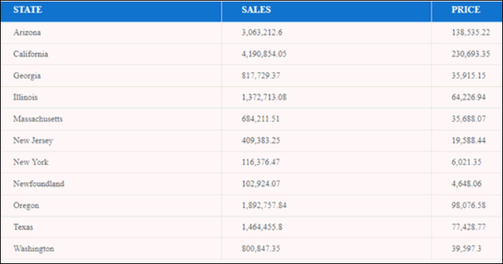

FTL Template for TXT Output

The following is the FTL Template for TXT output.

<#assign tabledata = Root.bands.ReportData>

<#list tabledata as Cname>

${Cname.fields.COL0};${Cname.fields.COL1};${Cname.fields.COL2}

</#list>

**TXT Output:**

TXT Output for the above-mentioned code is as follows:

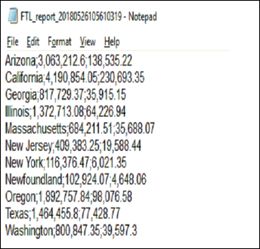

**Excel Output:**

To view the TXT File data in Excel, import the data into excel from “. TXT” file, and then view the output in excel. The output appears as follows:

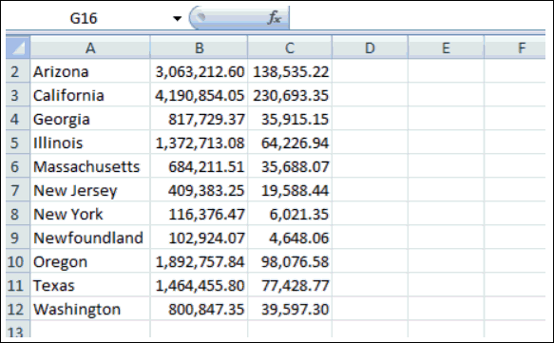

### Creating an Excel Template for Grouping

**Steps to Create an Excel Template for Grouping**

1. Open the **Excel Sheet.**

2. In the Excel sheet, enter the required **Columns** (highlighted as “1”).

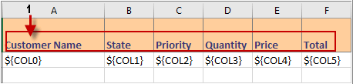

3. To extract the column values under the required columns, enter the column numbers as ${COL0}, ${COL1}, and so on (highlighted as “2”).

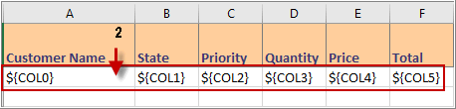

4. Enter the **Column Name** that must be used as the filter/parameter (highlighted as “3”).

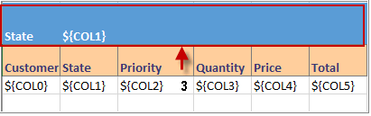

5. Now select the first two rows and group them under one band as “**Header**” as shown in the figure below.

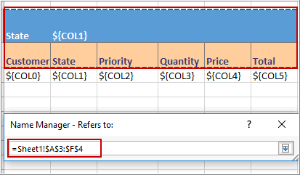

|  |
| --- |
| **Note**:   * Band Name in the ORBIT Publisher must be the same as the band name mentioned in the template. |

## Applying Templates to Publisher Report

### Applying Templates to Publisher Report

To view a Publisher Report in Excel, perform the following:

* Creating a Publisher Report
* Applying Excel Template to Publisher Report

### Applying Excel Template to Publisher Report

|  |
| --- |
| Note:   * Prior applying an **Excel Template** to a Publisher Report, the user must have an existing Template available in Microsoft Excel.  See *Creating an Excel Template* for more information. |

**Steps to Apply Excel Template to Publisher Report**

1. On the extreme right-hand side, click **Options**, and then click **Templates** (highlighted as “1”).

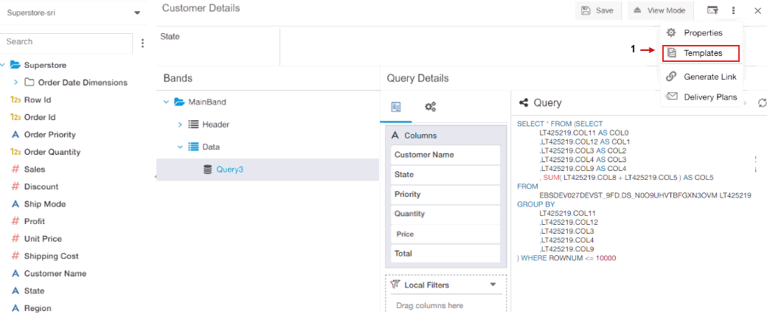

1. **Templates** dialog appears,to create a new template, click **New Template**.

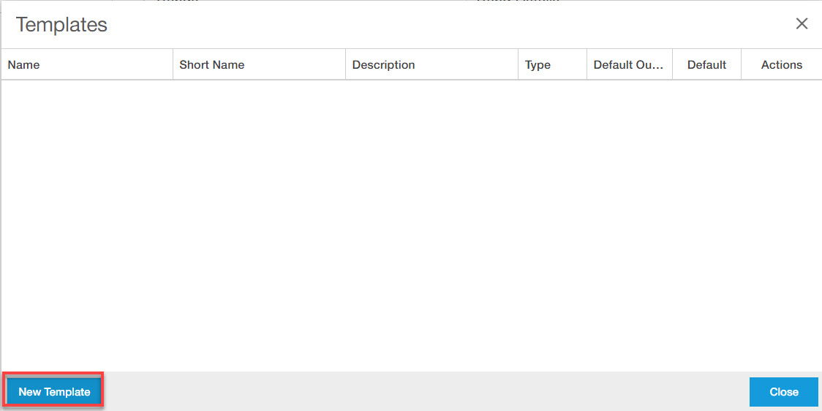

3. Enter the required details in the **Templates** dialogue box.

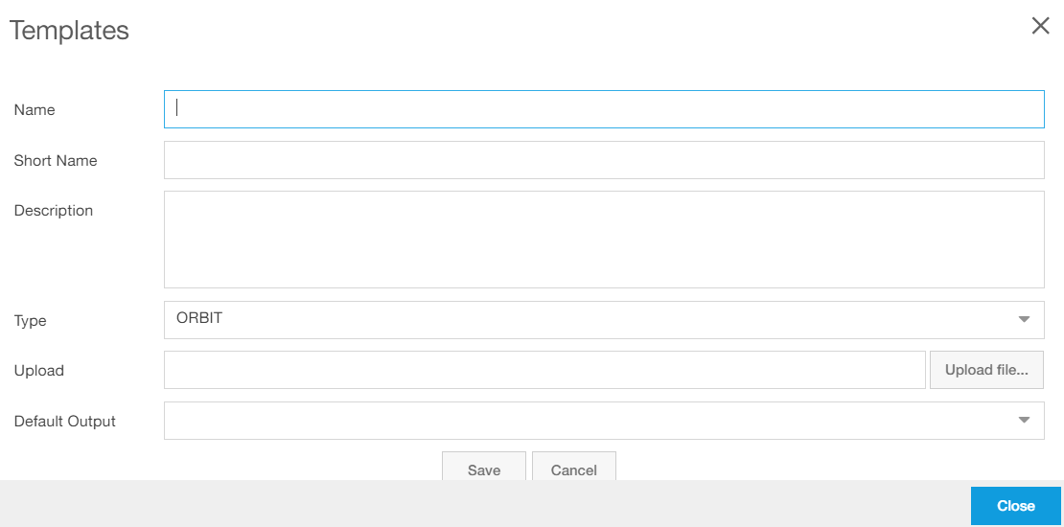

4.  In the **Name** box, type the name of the template.

5.  In the **Short Name** box, type the short name for the template.

|  |
| --- |
| Note:   * This field accepts only Aplha-Numeric without space |

6.  In the **Description** box, type the description.

7.  In the **Type** box, “**ORBIT**” is selected by default.

8.  To upload the required template, click **Upload file** that appears next to the **Upload** textbox.

9.  In the **Default Output** box, type/select the required default output option depending upon the template.

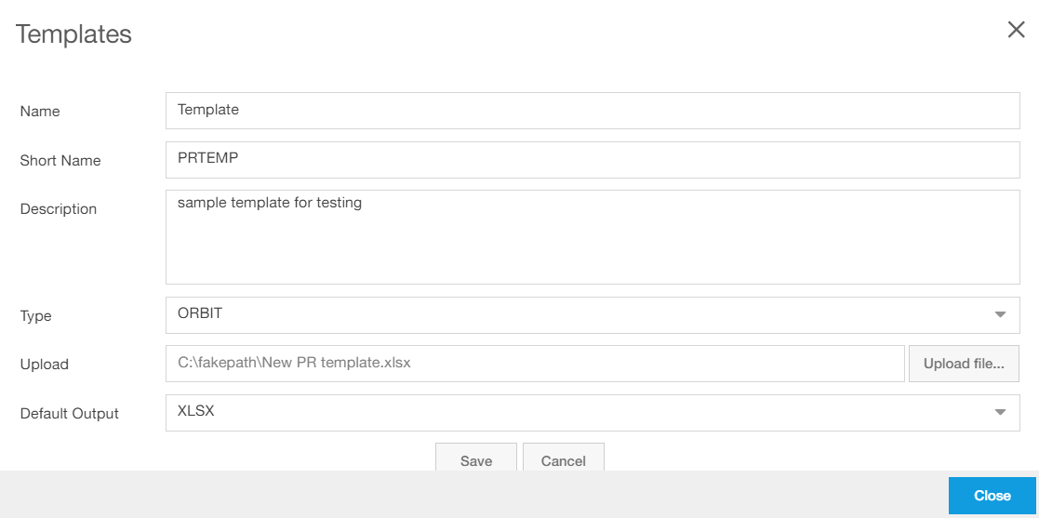

10. To upload the template, click **Save.**

11. The uploaded template appears under **Templates.**

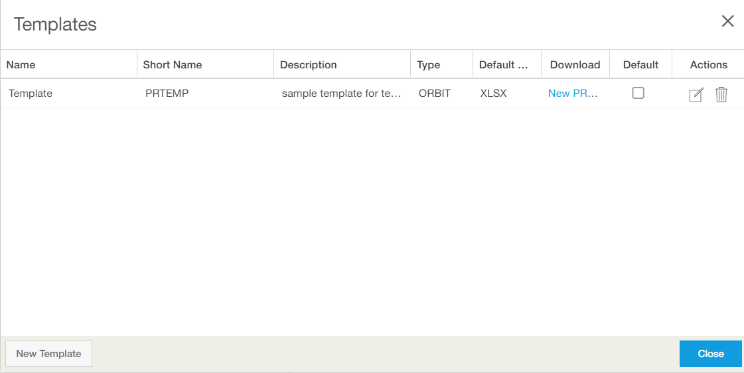

12. To make the template as a default template, select the required template, and then click **Make** **Default** (highlighted as “2”).

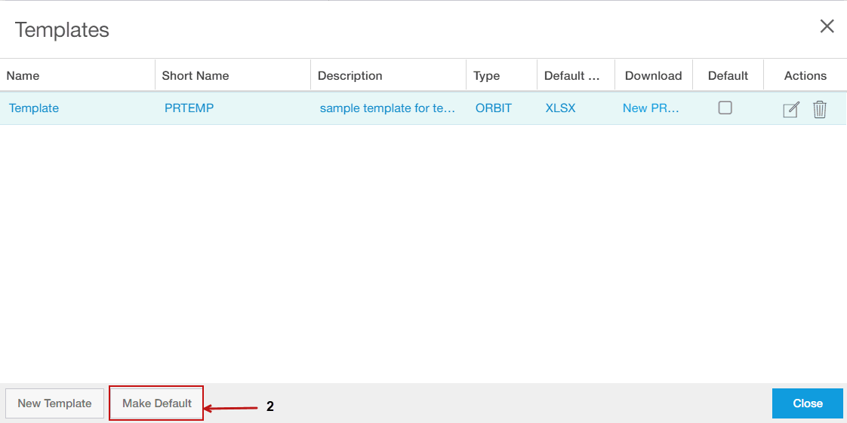

13. A checkmark (highlighted as “3”) appears in the **Default** checkbox for the selected template.

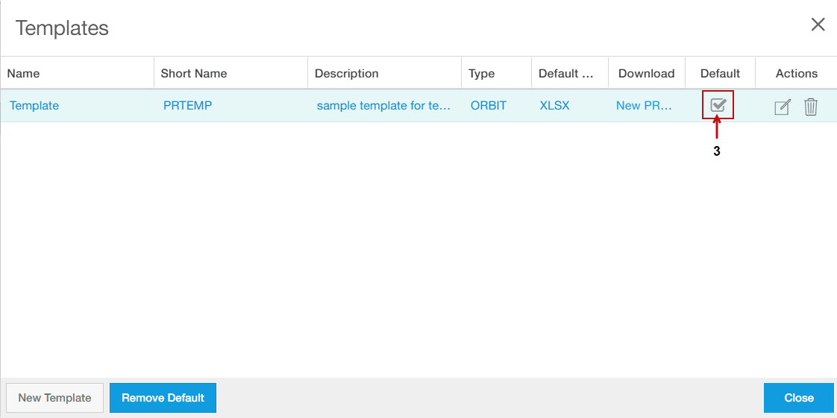

14. To remove the selected template from being a default template, click **Remove Default**.

15. To close Templates box, click **Close.**

### Applying Word Template to Publisher Report

|  |
| --- |
| Note:   * Prior applying the Word Template, User need to have an existing **Word Template.** See *Creating a Word Template* for more information. * **Word Template** need to be uploaded in a similar way as Excel Template in the Publisher report. For more details see *Applying Excel Template for Publisher Report* |

1. In the **View Mode**, in the **Select templat**e box, select the required Word Template file.

2. In the **Select Output** box, select the required option from the following:

* + HTML
  + PDF
  + DOCX

Output: Word

3. For the **State** parameter, provide the required value.

State: California

4. To run the report, click **Run**.

5. The report opens in a word document as follows:

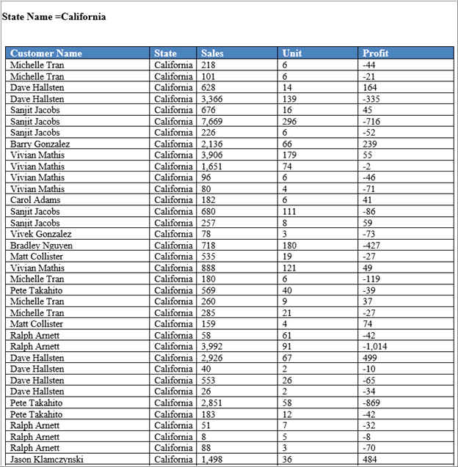

### Applying HTML Template to Publisher Report

|  |
| --- |
| Note:   * User need to have an existing HTML Template to be applied. See Creating an HTML Template for more information. |

1. Upload the **HTML template** as in *Applying Excel Template for Publisher Report* .
2. Save the report.
3. To Run the Publisher Report, perform the following:

a. On the Report menu, click **View Mode.**

b. The **View Mode** of the publisher report appears.

c. In the **Select template** box, select the available **HTML Template.  E.g** Template: Customer Details_HTML

d. In the **Select Output** box, select the required **Output Type** as HTML or PDF.

e. To run the report, click **Run.**

4.  The report appears as follows:

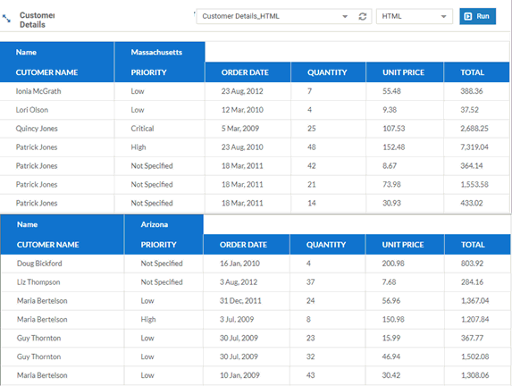

Here, the data for multiple states appears in HTML format as grouping has been applied

### Applying FTL Template to Publisher Report

|  |
| --- |
| Note:   * Prior applying the FTL Template user need to have an existing once. See How to Create an FTL Template for more information. |

1. Upload the FTL Template, as in Applying Excel Template to Publisher Report
2. Save the Report.